**cd ..**







Desarrollo Front-End Web

**Grupo:** 2

**Nombre del grupo:**

DevelopersEC

**Integrantes:**

Marlon Cevallos

Michael Gudiño

Carla Iza

Steven Jaramillo

**Docente:**

Jorge Edison Lascano



**Team 2**

**DevelopersEC**

**FashionStore**

**Git:** [**https://github.com/MarlonCevallos/DevelopersTeam2FashionStore.git**](https://github.com/MarlonCevallos/DevelopersTeam2FashionStore.git)

**Mongo Atlas: mongodb+srv://MarlonTeam2:2022@**[**cluster0.pvig5s9.mongodb.net/FashionStoreDB?retryWrites=true&w=majority**](http://cluster0.pvig5s9.mongodb.net/FashionStoreDB?retryWrites=true&w=majority)

**Video:**

[**https://youtu.be/PHkuajb5W2o**](https://youtu.be/PHkuajb5W2o)

1. **GitHub collaboration**

<https://github.com/MarlonCevallos/DevelopersTeam2FashionStore.git>

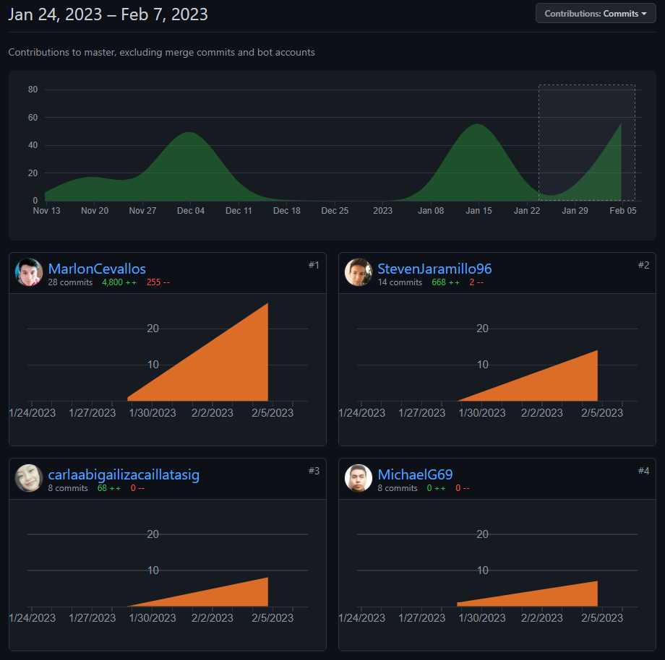

**Collaboration Report**

| **Activity report** | | | |
| --- | --- | --- | --- |
| **Developer** | **Request** | **Implementation** | **Other Activities** |
| Marlon Cevallos | * REQ001 Access to the system * REQ002 Functionality menu * REQ003 Product sales record * REQ004   List of products sold   * REQ005 Calculation of earnings for each product sold * REQ020 Product Sales Report | * Desing and implementation REQ001 * Desing and implementation REQ002 * Desing and implementation REQ003 * Desing and implementation REQ004 * Desing and implementation REQ005 * Desing and implementation REQ020 * Three business rules | * Github repository creation * Creation of project code base structure * Creation of the database in mongoDB of the project * AWS Cloud project deploy * Organization of activities of the working group * Review of clean source code and in English language * Creation of the document for official delivery of the activities * Development of SALES report |
| Michael Gudiño | * REQ006   Register Supplier   * REQ007   List Supplier   * REQ008   Modify Supplier   * REQ009   Supplier Menu | * Design and implementation REQ006 * Design and implementation REQ007 * Design and implementation REQ008 * Design and implementation REQ009 | * Product Backlog Design * User Stories Design * Functional Requirements Design * Modification of Sketches * Review of clean source code and in English language |
| Carla Iza | * REQ0010   Customer Menu   * REQ0011   Add Customer Design   * REQ0012   Customers list Design   * REQ0013   modify Customers | * Design and implementation REQ0010 * Design and implementation REQ0011 * Design and implementation REQ0012 * Design and implementation REQ0013 | * Modification of Functional Requirements * front-end and back-end architectural design * URIS documentation services * business rule requirements |
| Steven Jaramillo | * REQ0014   Cellar register design   * REQ0015   Inventory list design   * REQ0016   Design and logic of the computation of time, from the date of entry of a product to its exit.   * REQ0017   modify inventory or cellars. | * Design and implementation REQ0014 * Design and implementation REQ0015 * Design and implementation REQ0016 * Design and implementation REQ0017 | * Lifting and updating of functional requirements. * Design of application architecture, Front-end. * Design and update of class diagram. * Design and modification of sketches for interfaces and web pages. * Collaboration in the creation and presentation of deliverable documents. |

**Details**

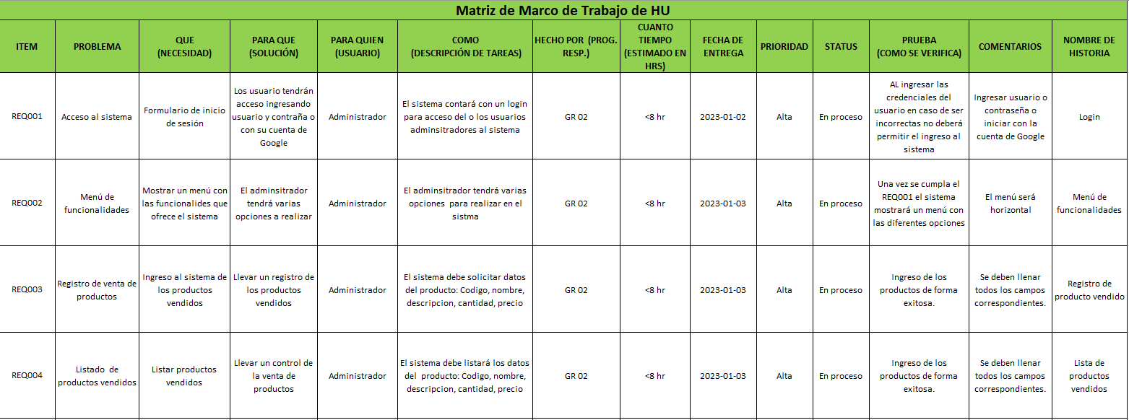

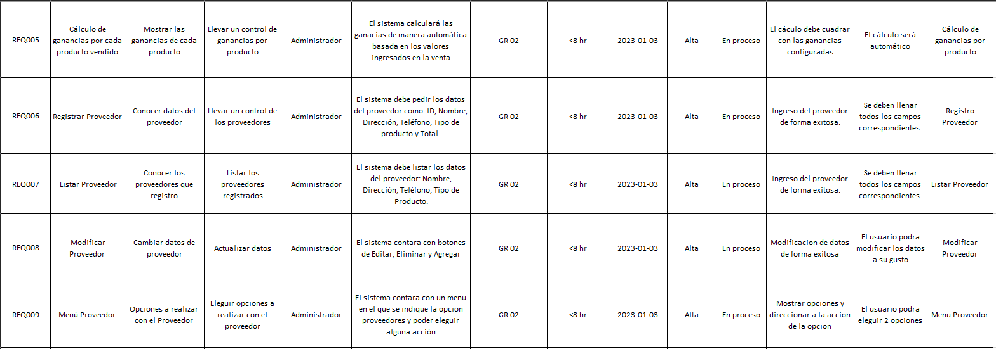

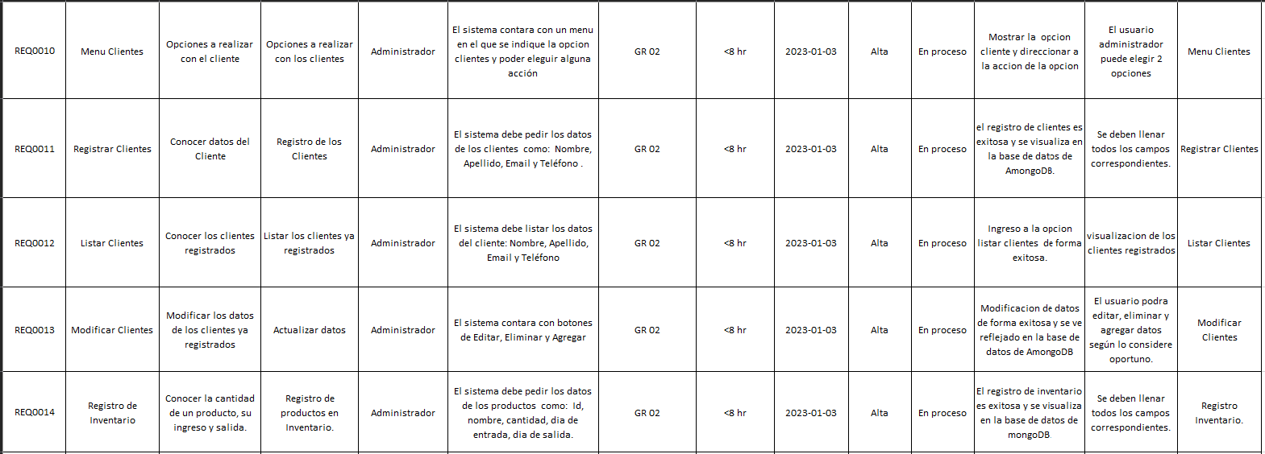

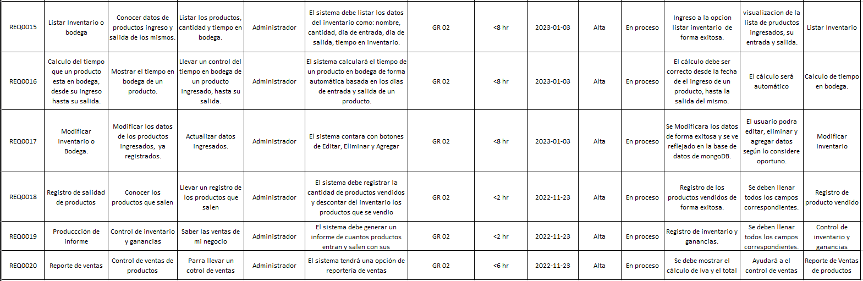

1. **Design (sketches) of the 16 web pages/forms**

**2.1 Design:**

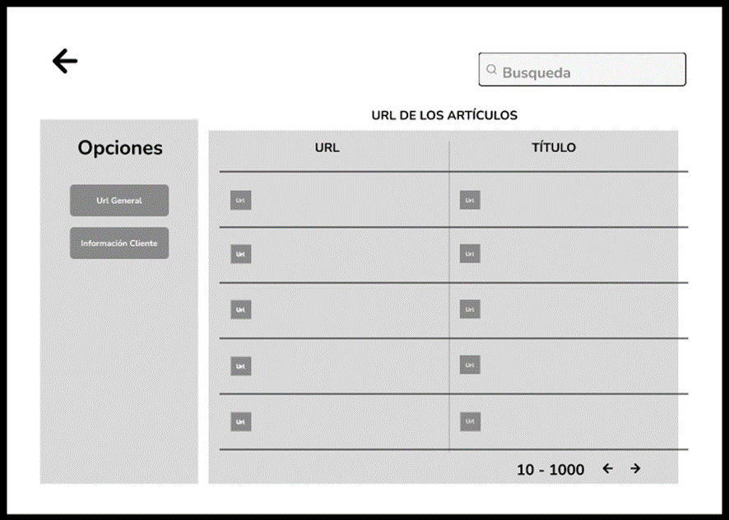

**2.2 Design:**

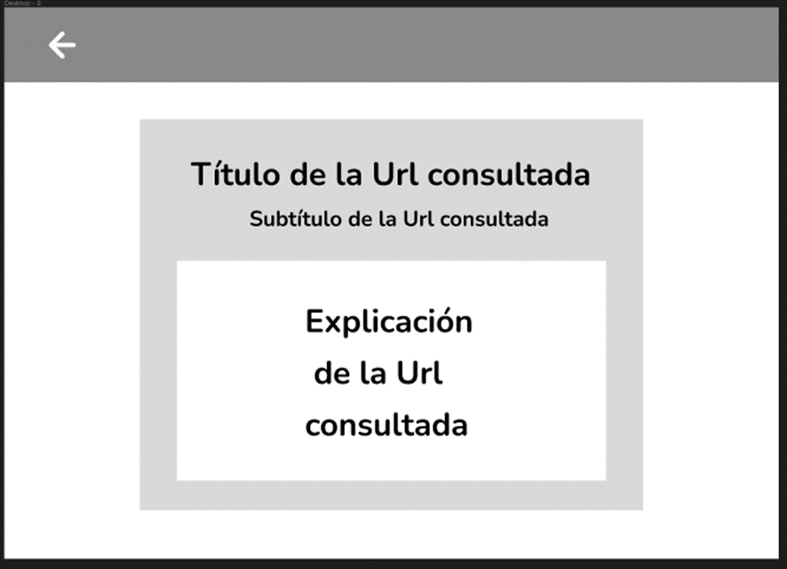

**2.3 Design:**

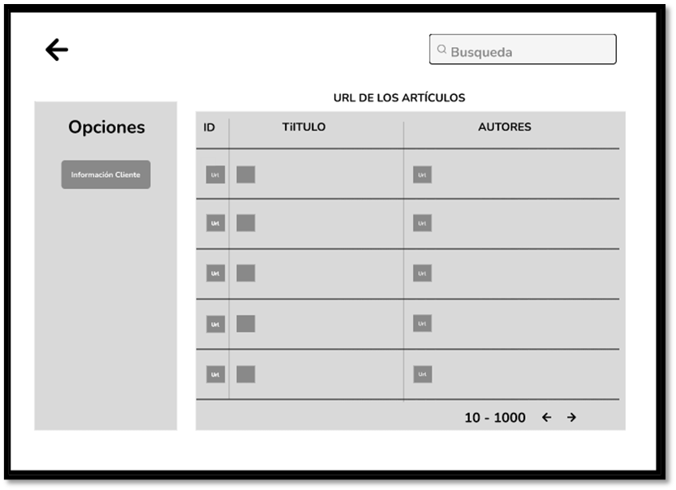

**2.4 Design:**

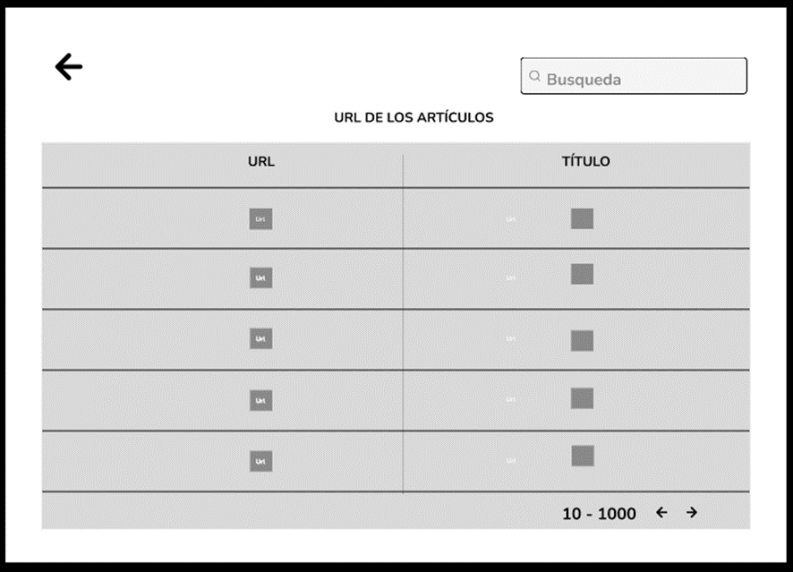

**2.5 Design Api Sketches:**

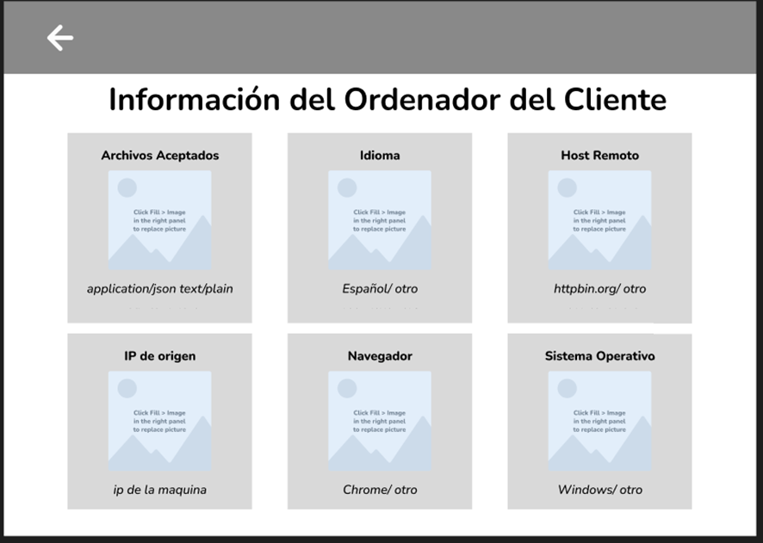

**USER INTERFACES FOR YOUR PROJECT**

**2.6 Login Design**

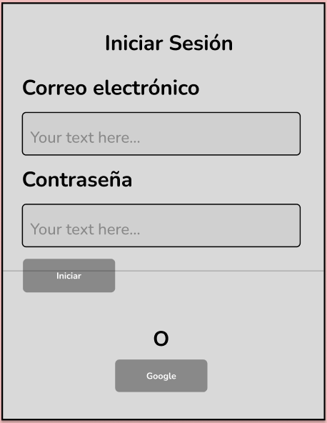

**2.7 Home Page Design**

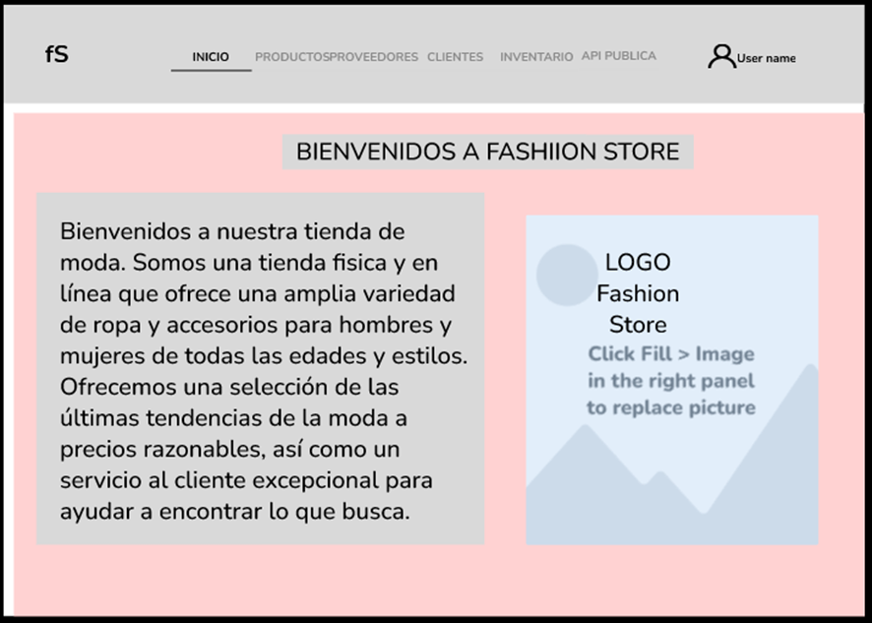

**2.8 Product List Design**

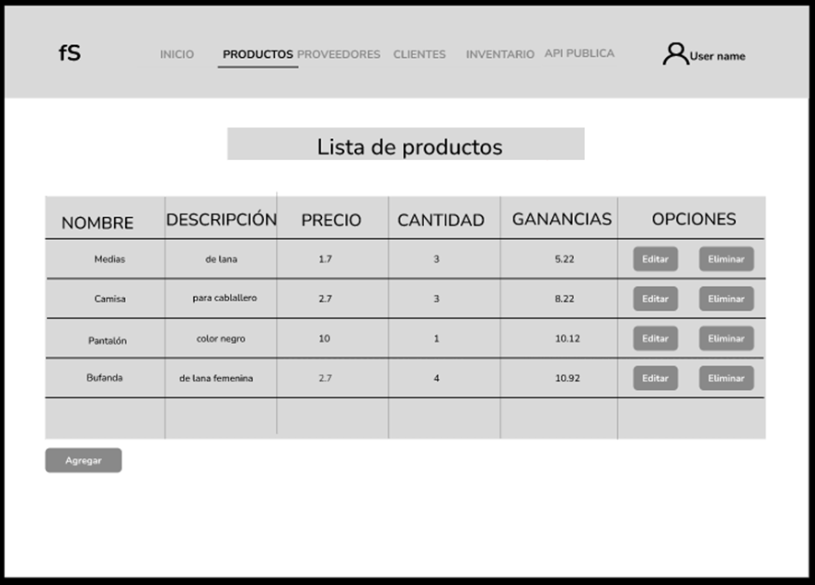

**2.9 Design Add Product**

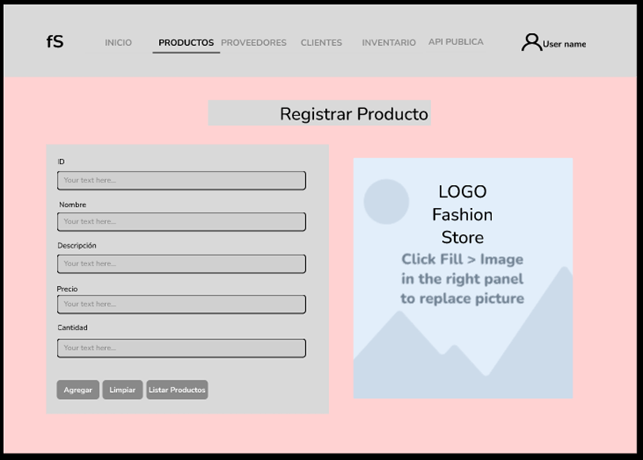

**2.10 Sales report design**

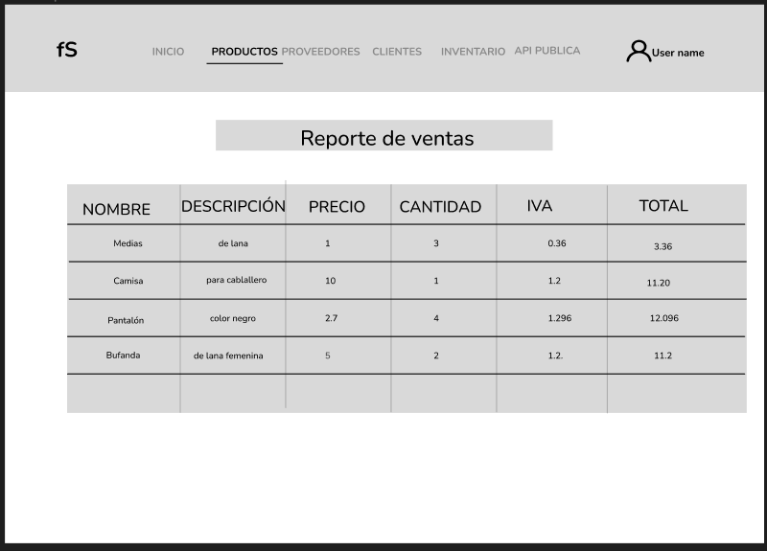

**2.11 Provider List Design**

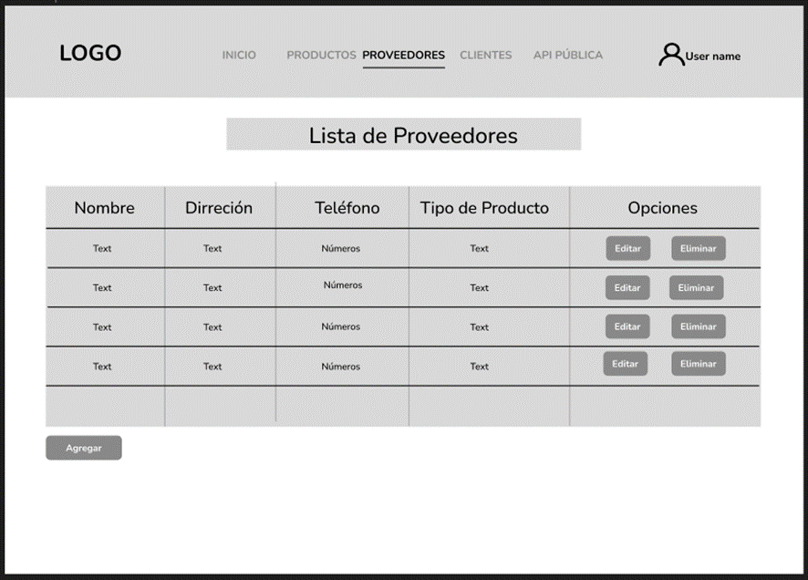

**2.12 Add Provider Design**

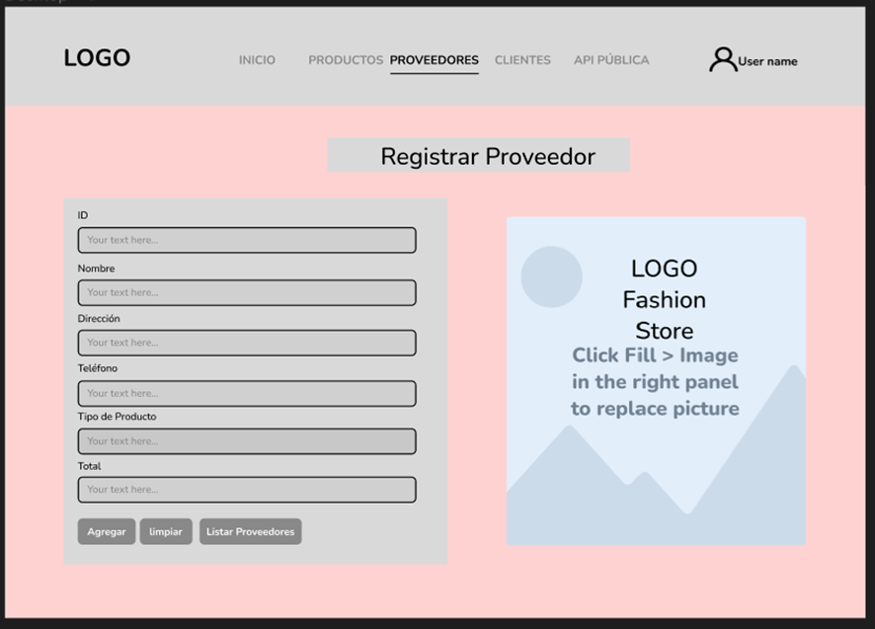

**2.13 Customer List Design**

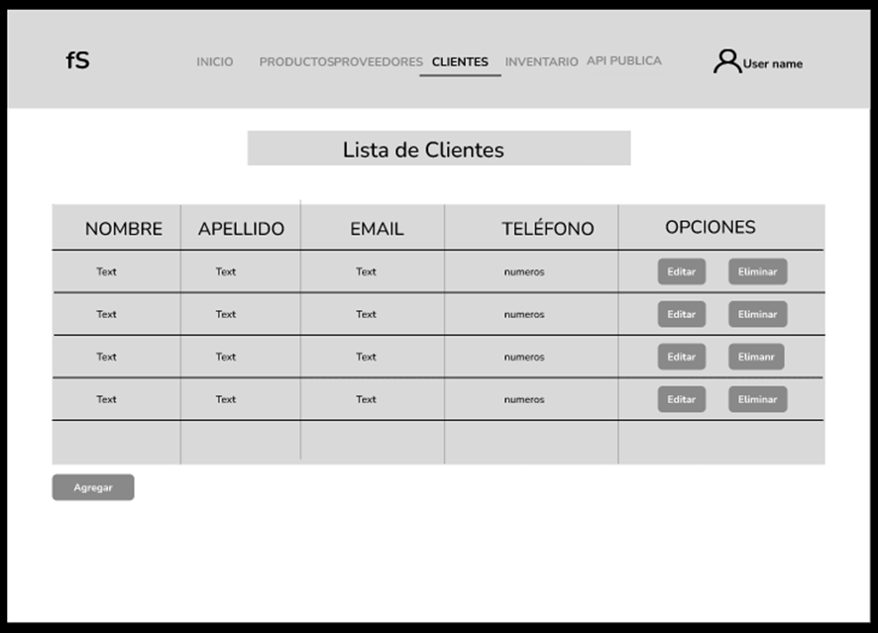

**2.14 Design Add Customer**

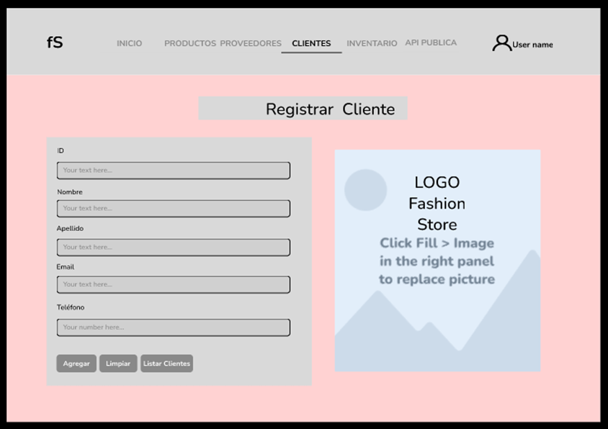

**2.15 Inventory List Design**

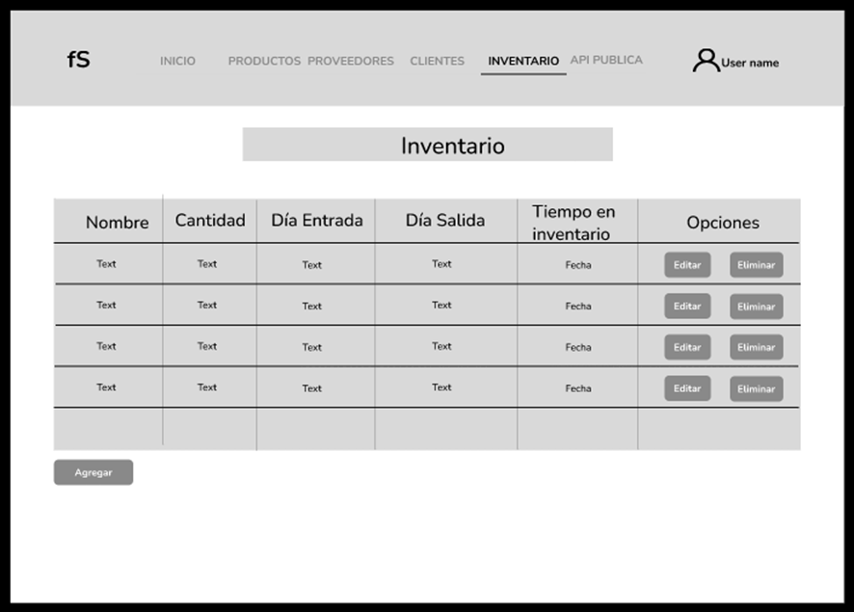

**2.16 Design Add inventory**

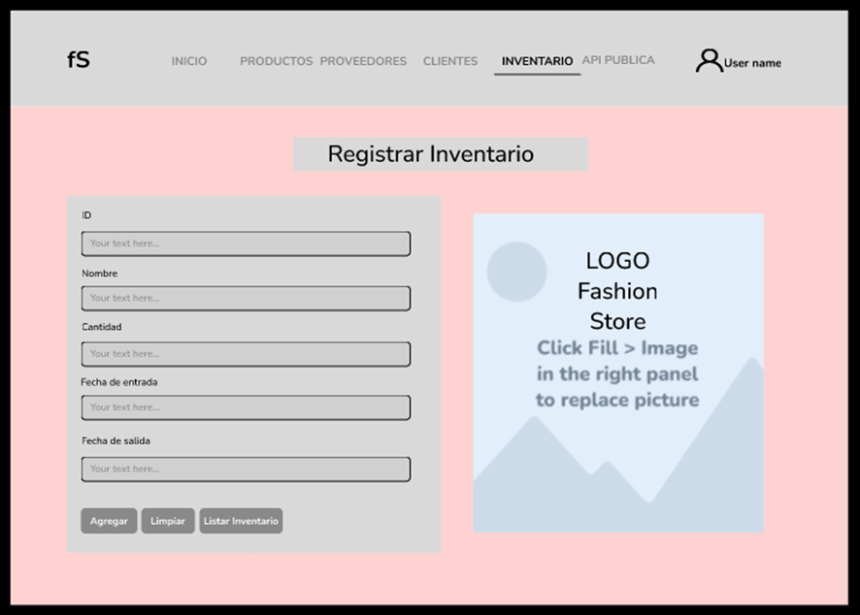

**3. Web Clients + Web Services (GET, POST) + DB**

* **Products** - Data Base and Web Service GET

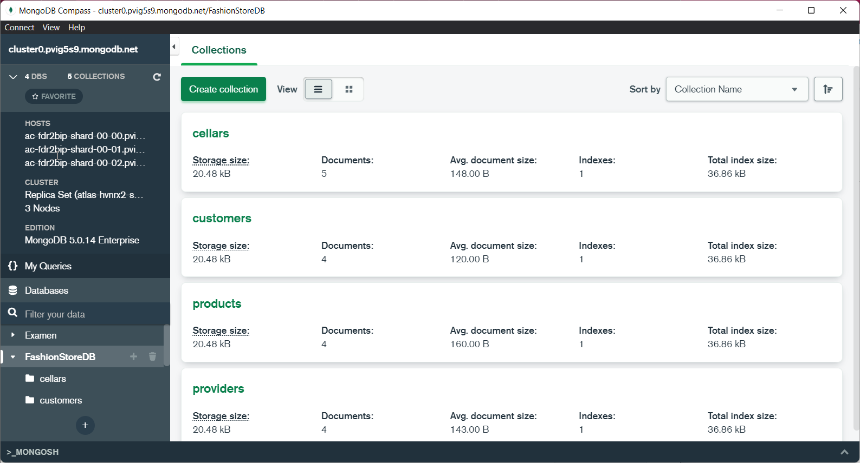

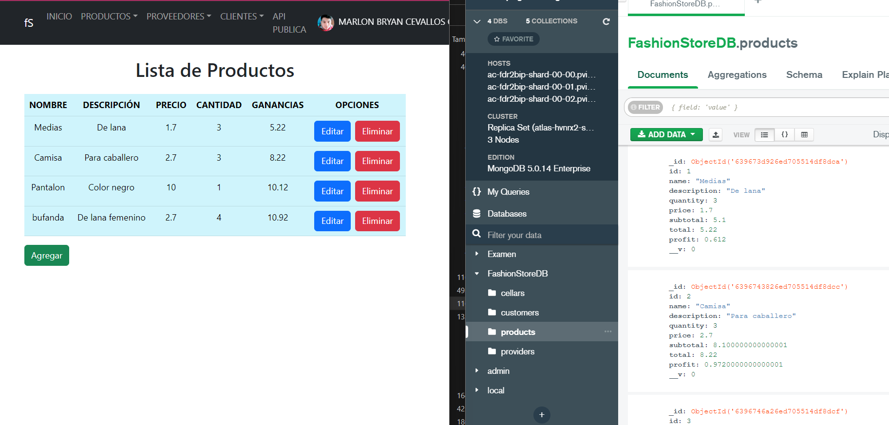

* **Products** - Data Base and Web Service POST

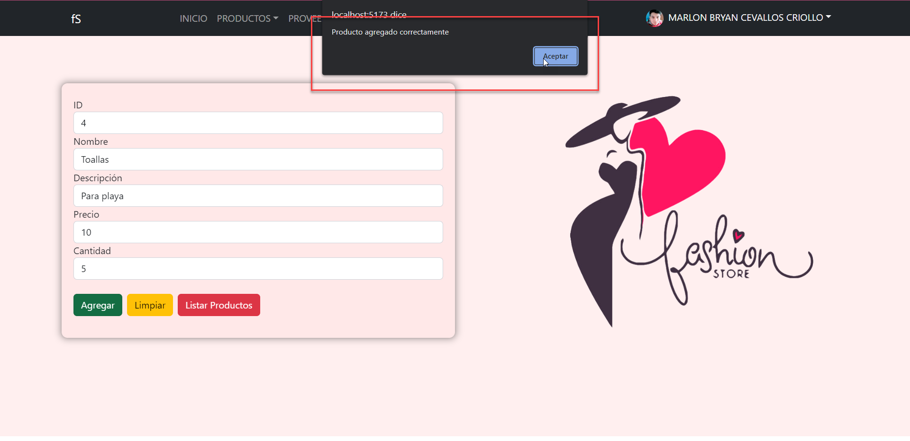

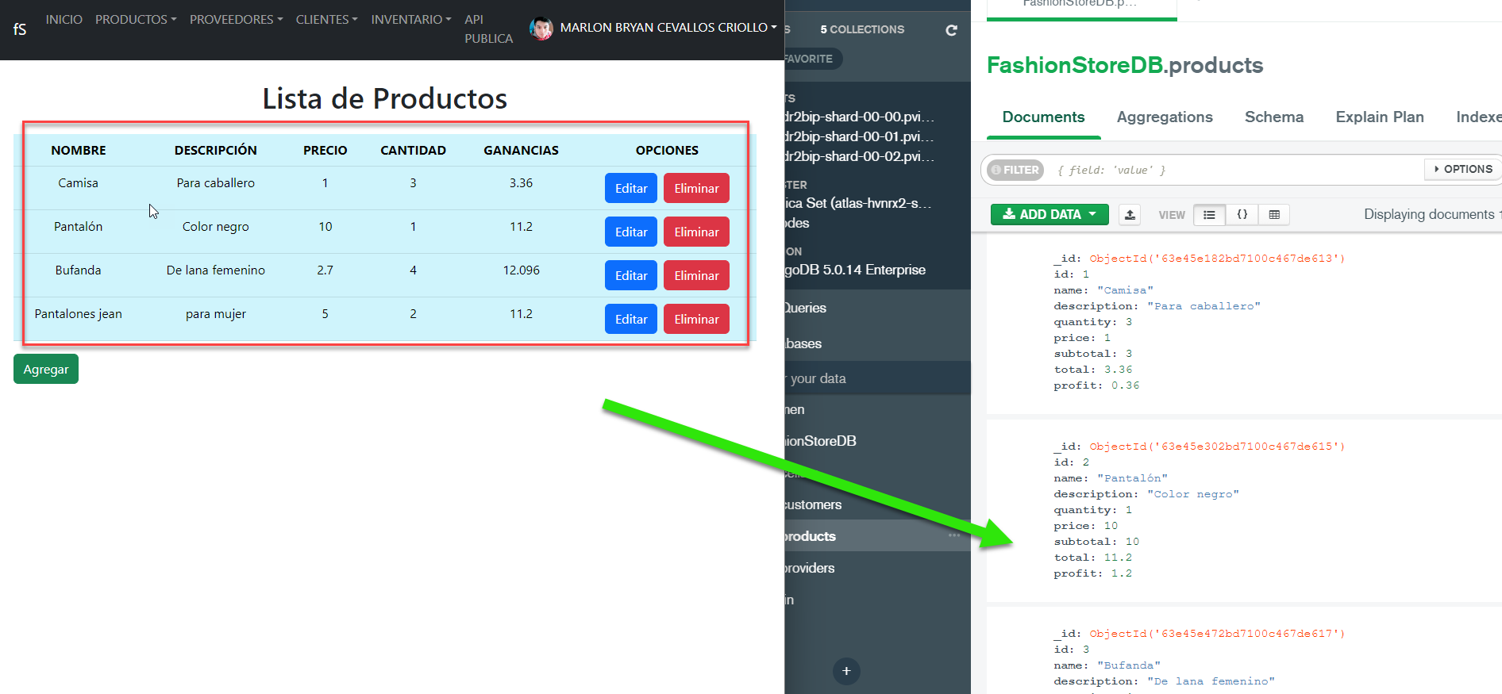

* **Providers** - Data Base and Web Service GET

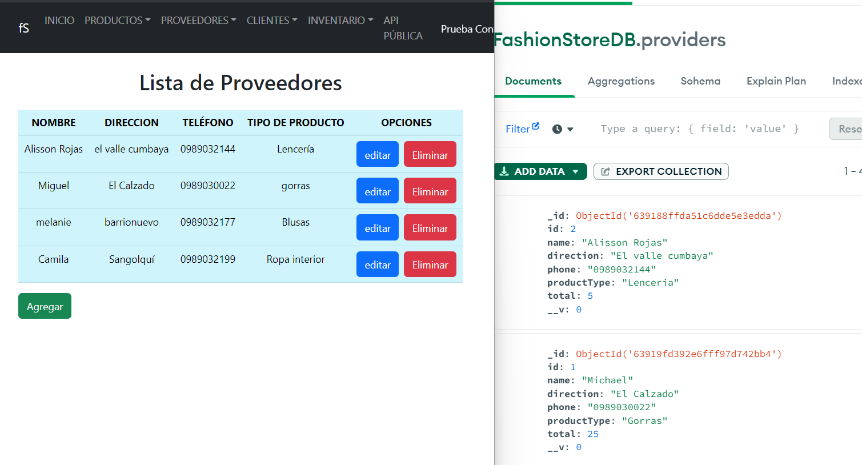

* **Providers** - Data Base and Web Service POST

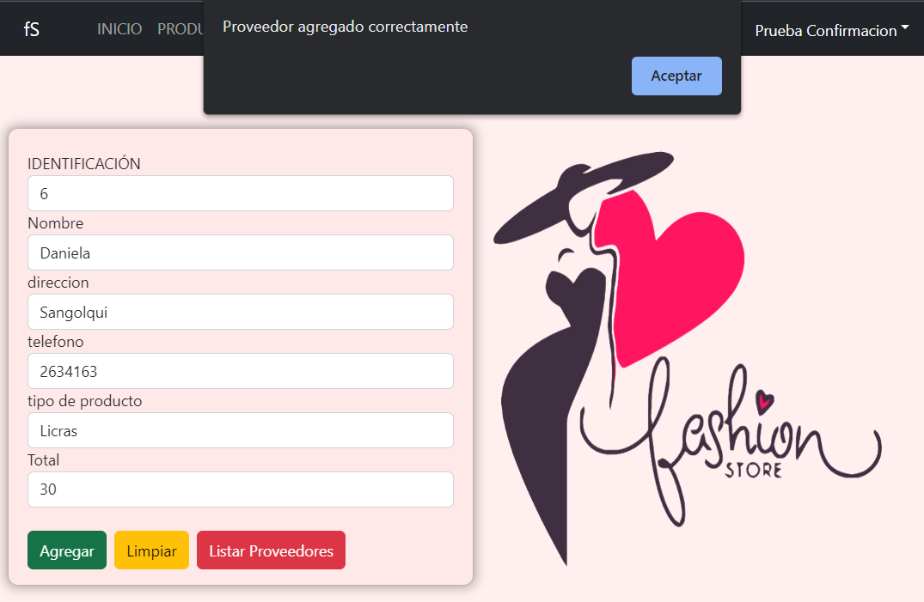

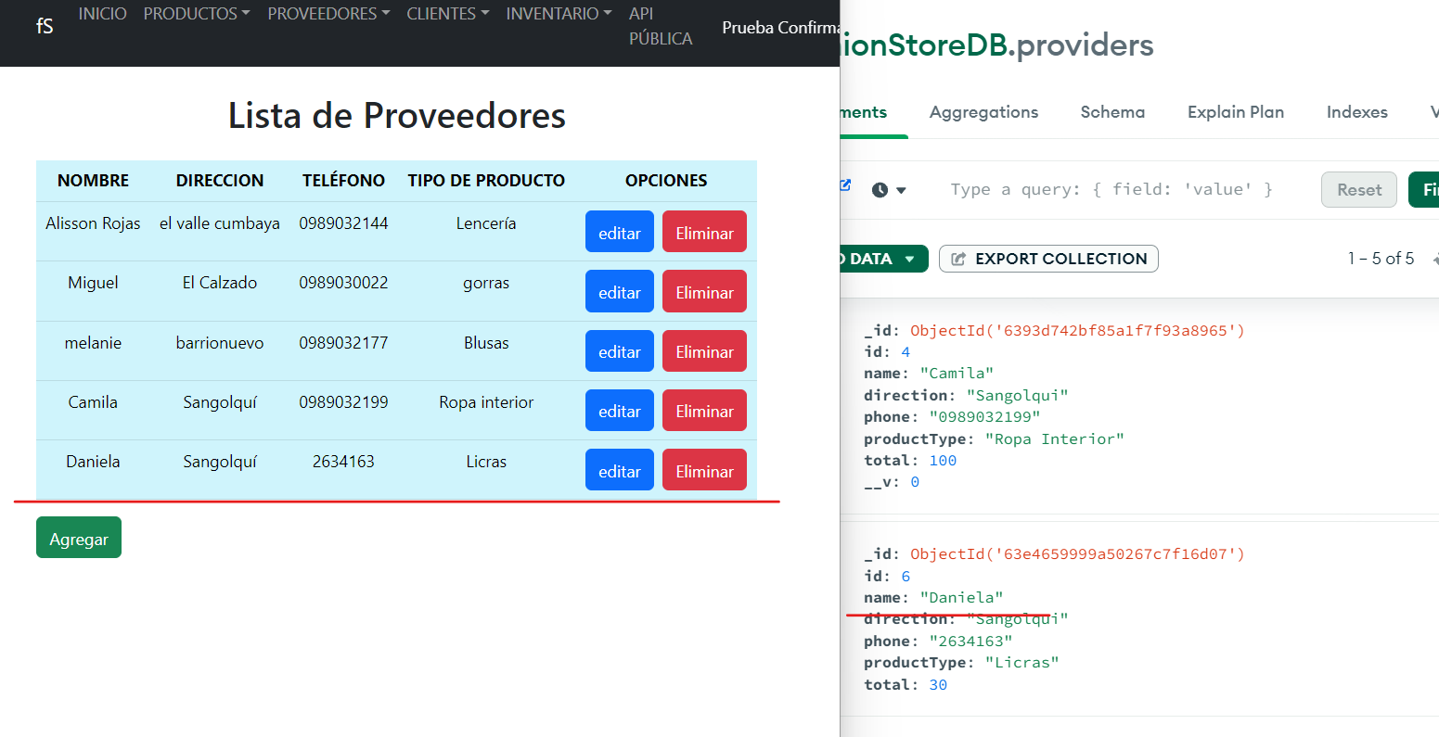

* **Costumer** Data Base and Web Service GET

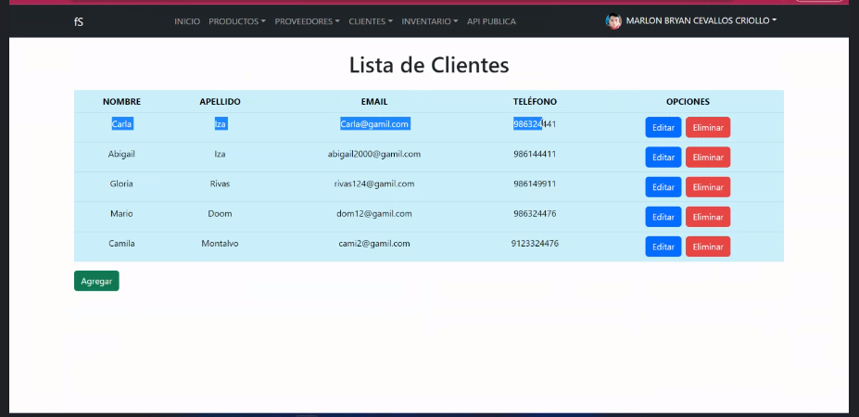

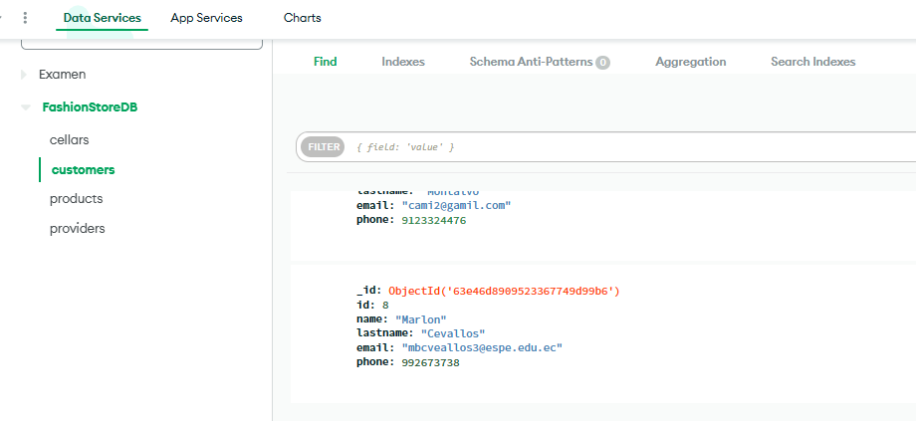

* **Costumer** - Data Base and Web Service POST

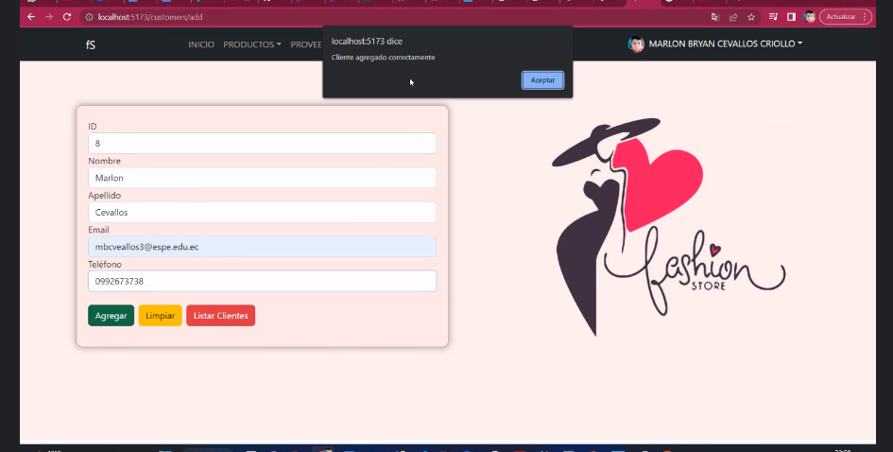

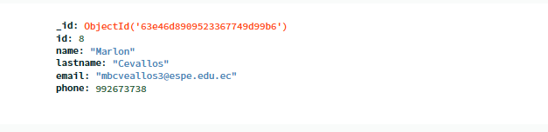

**Web Clients + Web Services (PUT, DELETE) + DB**

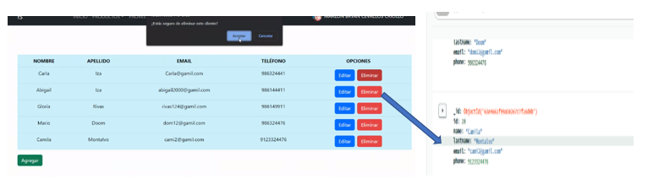

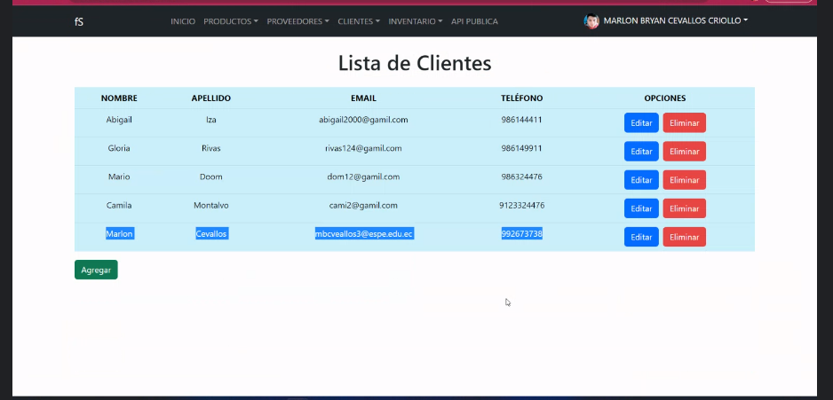

* **Cellars** - Data Base and Web Service GET

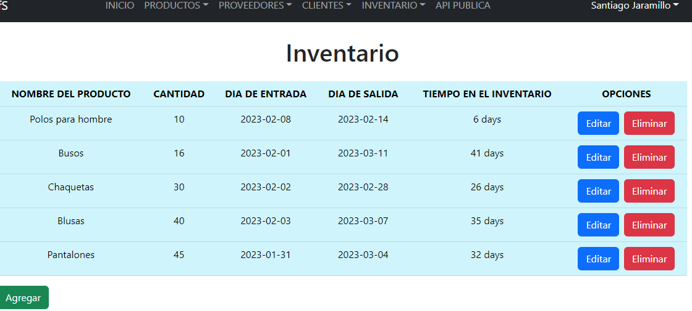

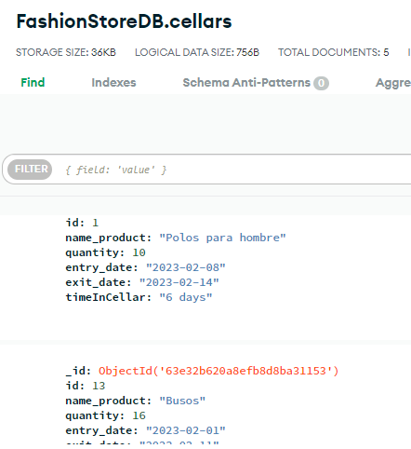

* **Cellars** - Data Base and Web Service POST

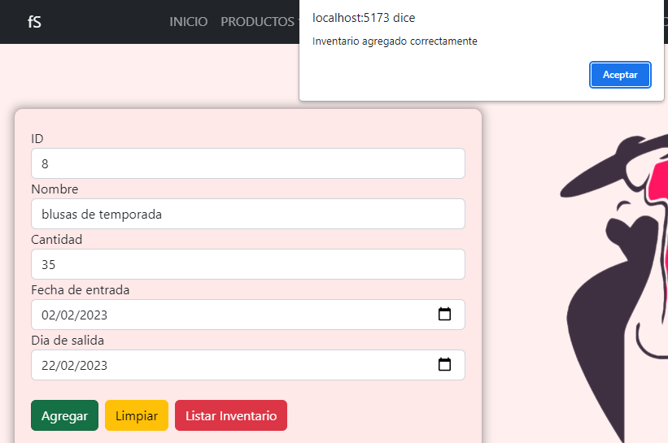

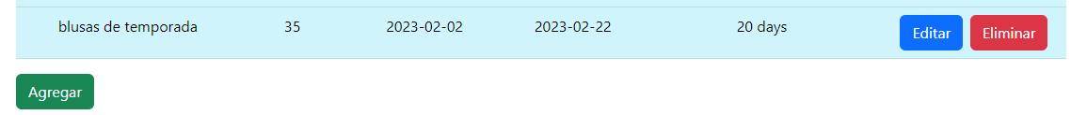

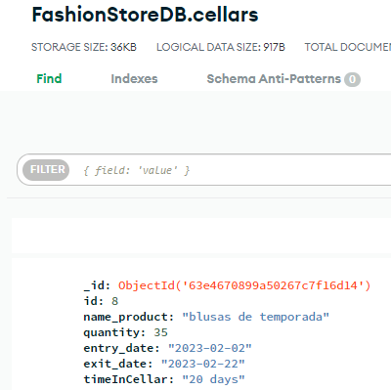

**4. Web Clients + Web Services (PUT, DELETE) + DB**

* Products - Data Base and Web Service PUT

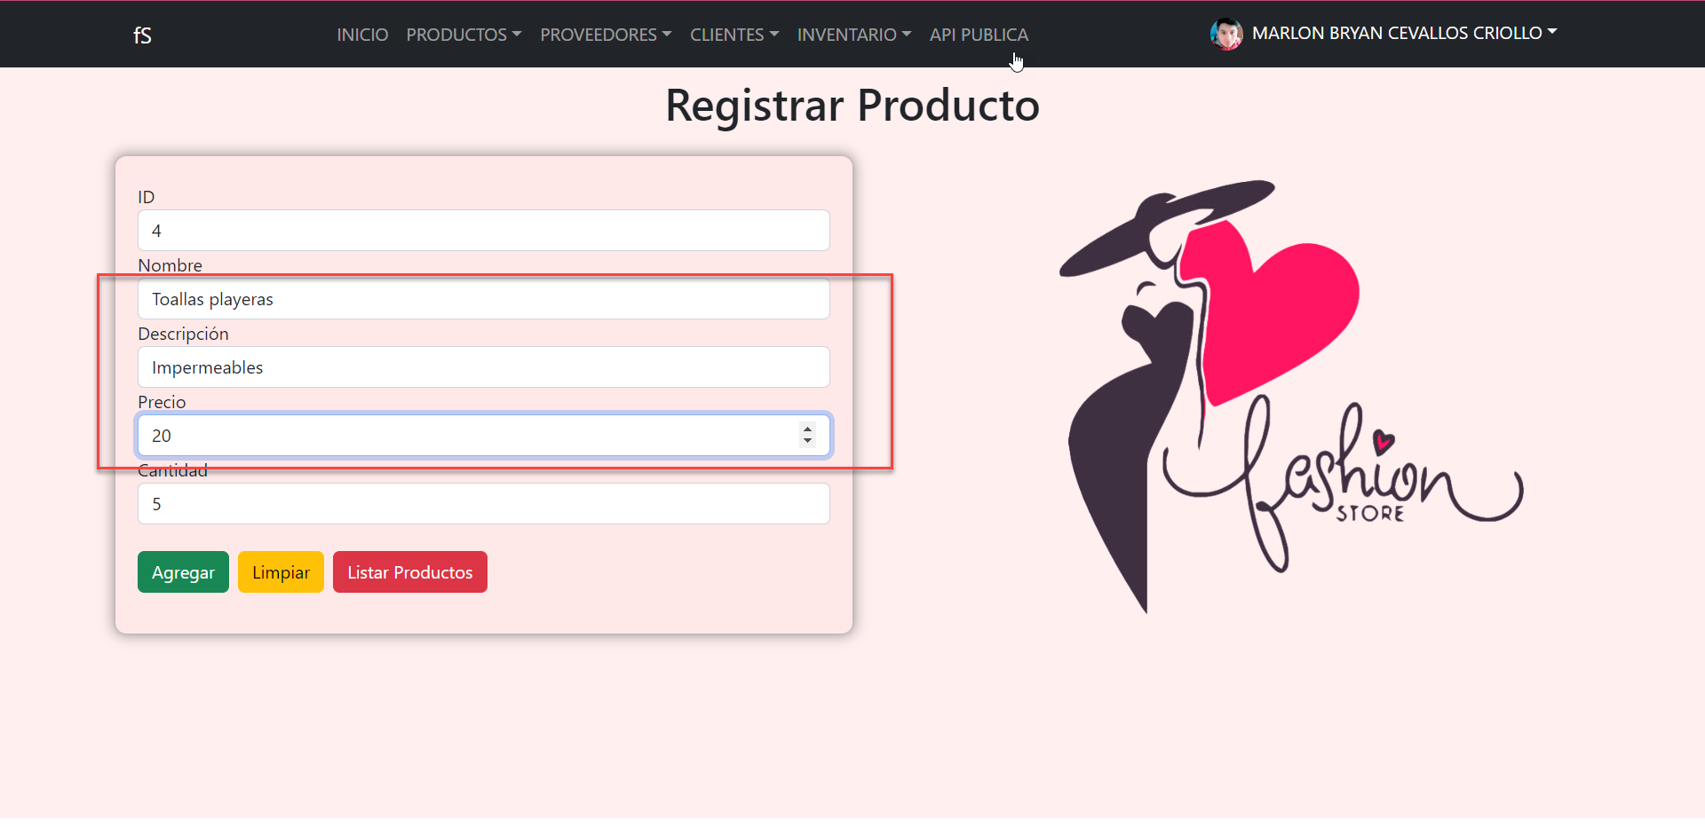

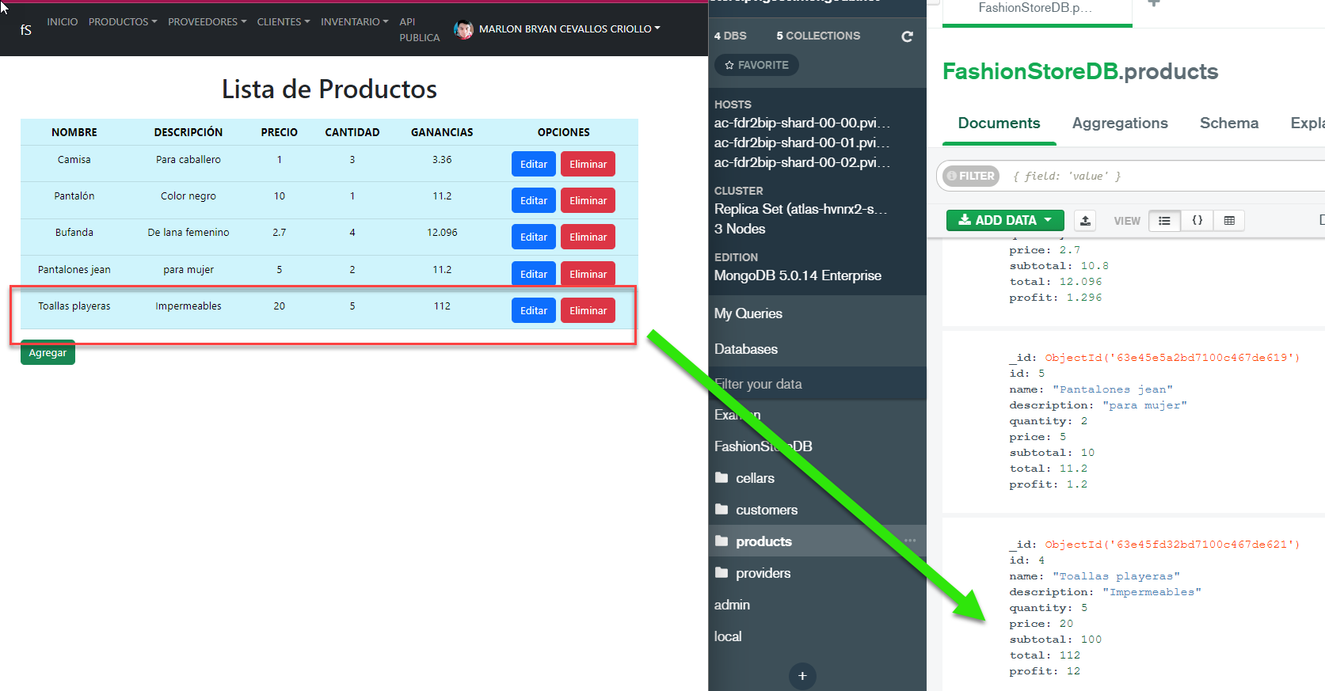

* **Providers** - Data Base and Web Service PUT

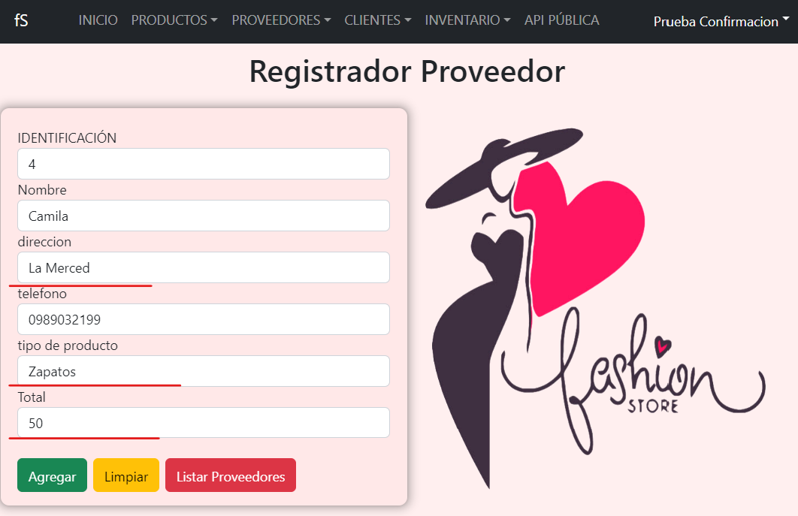

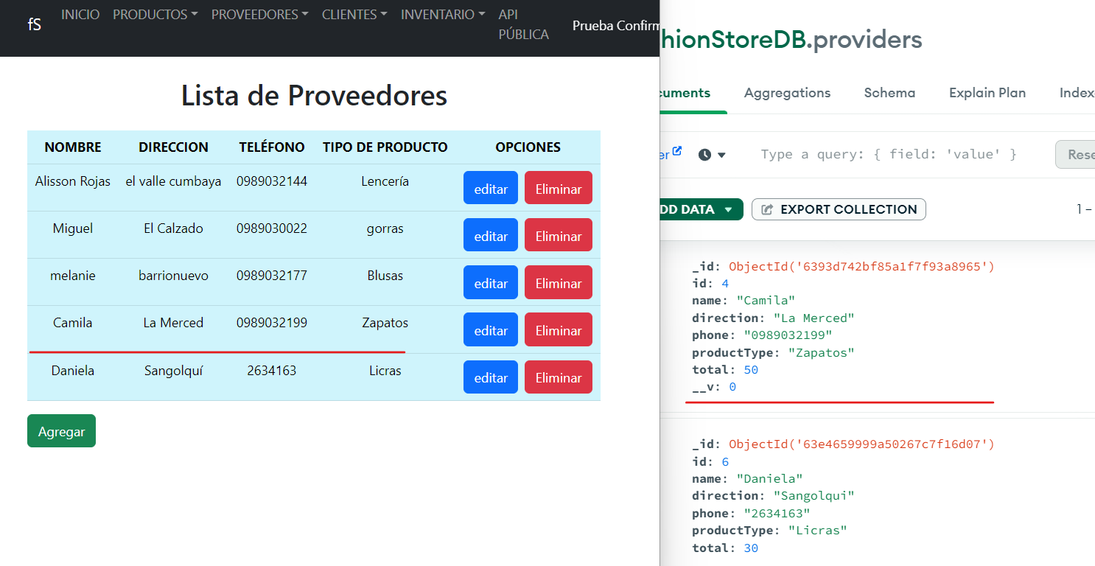

* **Products** - Data Base and Web Service DELETE

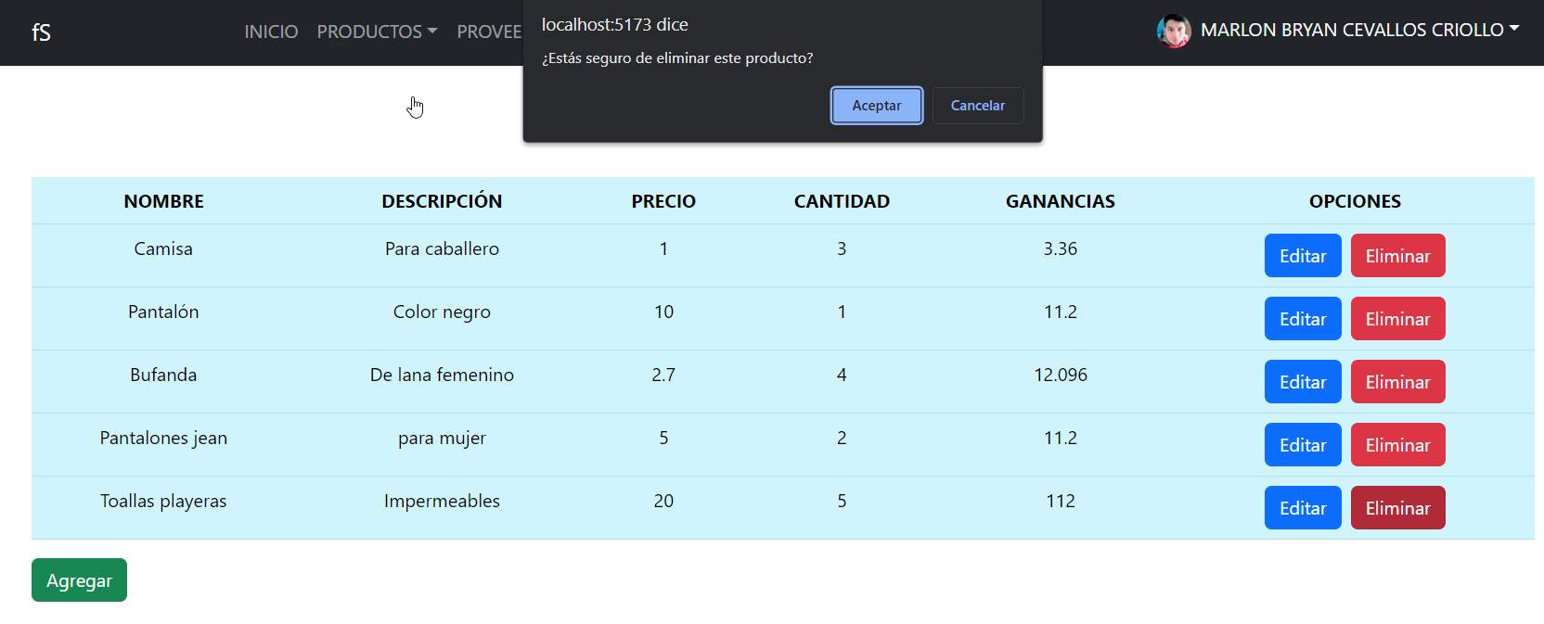

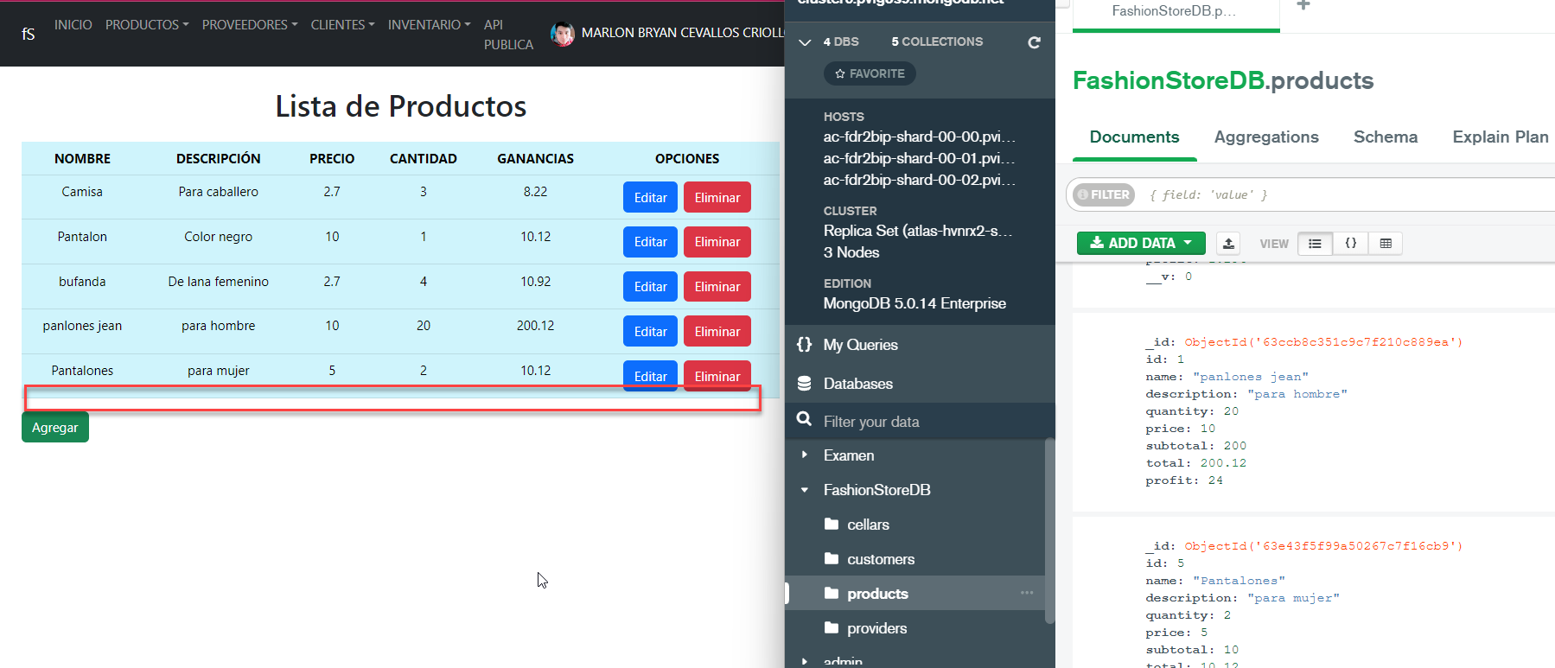

* **Providers** - Data Base and Web Service DELETE

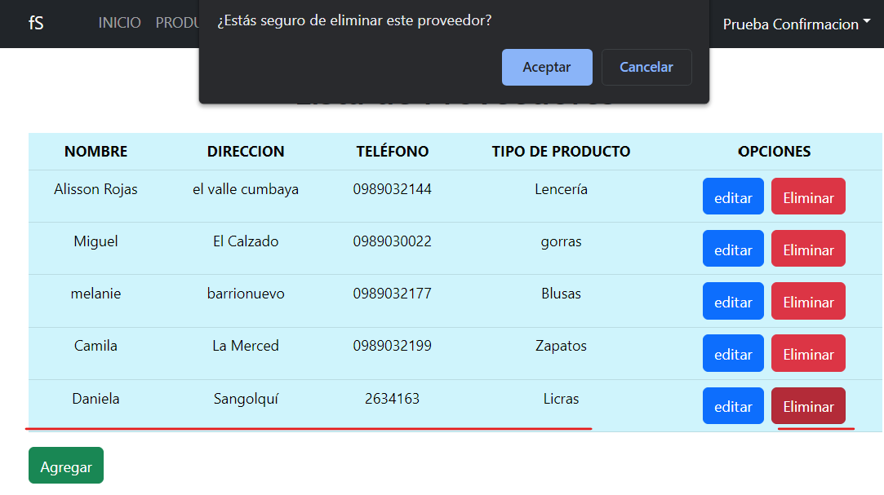

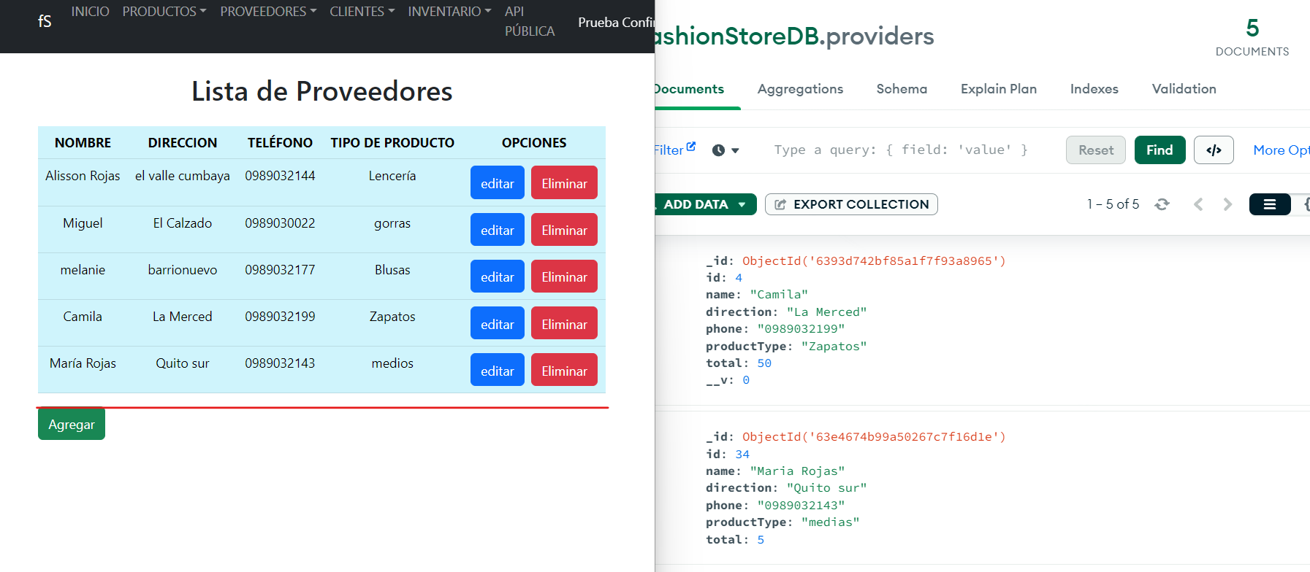

* Cellars - Data Base and Web Service PUT

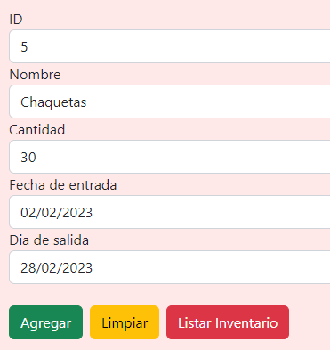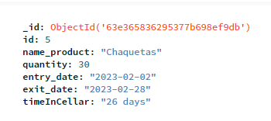

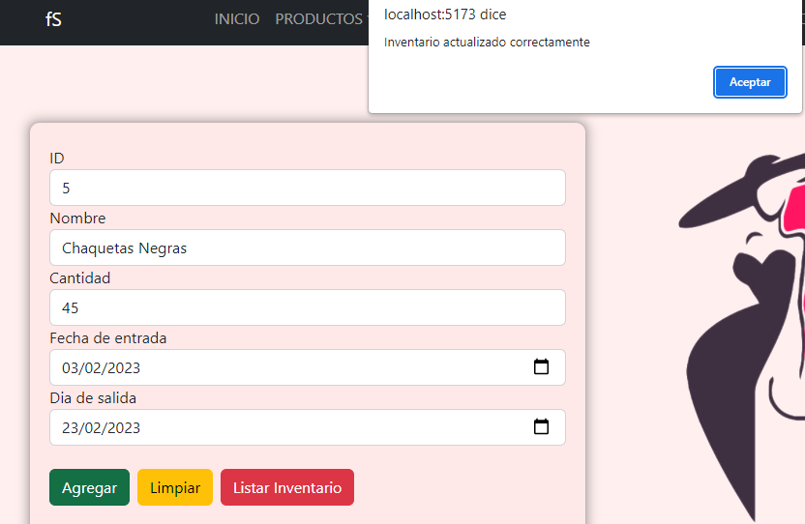

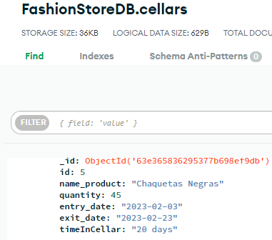

* Cellars- Data Base and Web Service DELETE

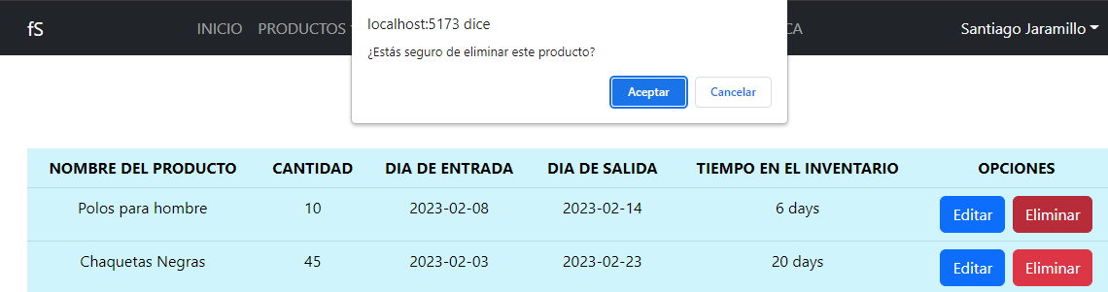

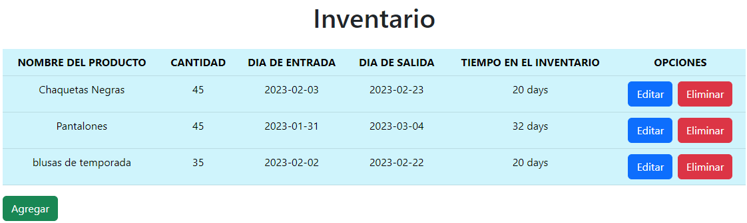

**5. Web Clients + Web services( Business logic) + DB**

**Profit by product**

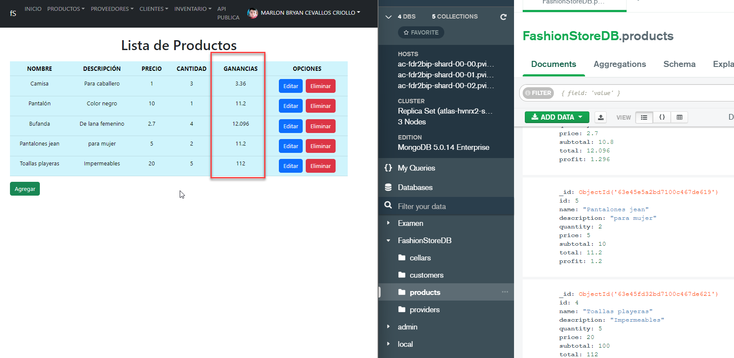

**Calculation of days in cellar**

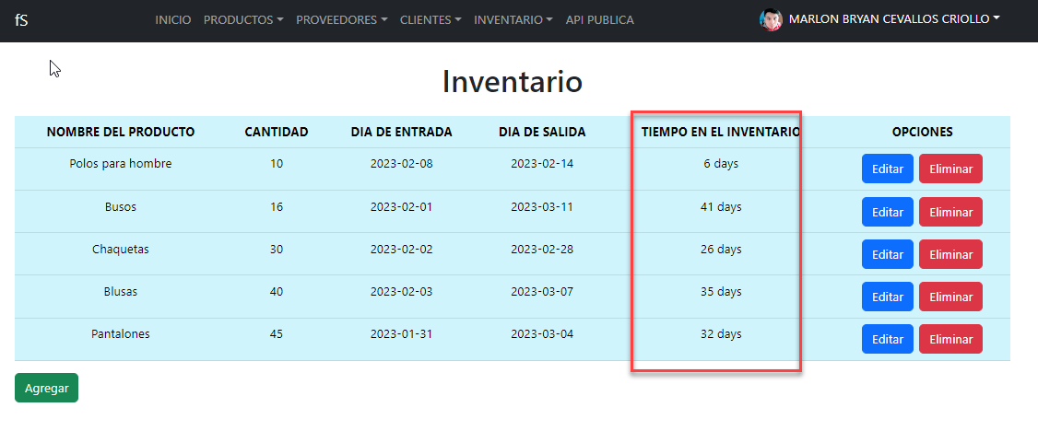

**Calculation IVA**

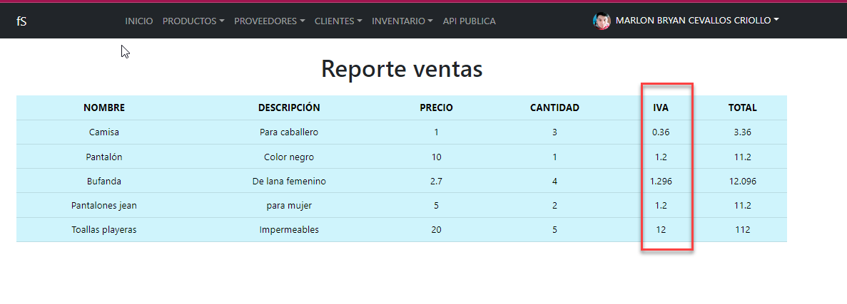

**Calculation total**

